AI BASED ENERGY MANAGEMENT

# Keywords

Control of smart grid, Energy management system, Artificial Intelligence, Machine Learning, Decision making.

# Introduction

Energy management and AI smart grid is basically an advanced electric power system of tomorrow that integrates the state of-the-art power electronics, computers, information and communication. Unfortunately, our present power grids are too old, obsolete, inefficient, unreliable, and provide inadequate protection for faults. We the existing energy resources, generating power effectively and intelligently is an equally important agenda. Supplementing the establishment of large power plants from conventional energy sources, there is also a need to focus on distributed small-scale generation of power particularly from renewable energy sources. Although Distributed Energy Resources need additional infrastructure and investment to connect them to the grid, these technologies obviate the need for an expensive transmission system and reduce transmission and distribution losses. Raspberry pi will collect the weather information to optimize the power supply efficiently and it also upload the collected data from sensors how much power is consumed by every appliance. The appliances are also optimized by the system as that required.

# Objective

The overall aim of the project is to develop a AI-based decision-making tool to improve energy management of smart grid that balances different stakeholders’ interests including energy suppliers - profit, end users - energy consumption and bill, governments - net zero carbon goal, while ensuring demand-supply balance. In order to reach this aim, the project has the following key objectives:

1. Investigate computational models of electricity markets of smart grid systems at different scales, including smart home or distributed resource systems.
2. Develop machine learning algorithms for demand response, including dynamic pricing, from energy suppliers’ perspective.
3. Develop machine learning algorithms to support smart scheduling of power consumption at peak time from energy users’ perspective.
4. Multi-criteria optimization of energy management from both energy suppliers’ and end users’ perspectives.
5. Test and evaluate the proposed approaches in real-scenario experimental platforms.

# Methodology

# Component Details:

# ESP32

# Solar panel

# Relay

# Current Sensor

# Voltage Sensor

**AI POWER MANAGEMENT BLOCK diagram**

POWER SUPPLY

SOLAR VOLTAGE SENSOR

LOAD

ESP32

CURRENT SENSOR

EB /SOLAR

SWITCHING UNIT (RELAY)

EB POWER SUPPLY

SALE TO EB

L

L

Figure 3.1: Block Diagram

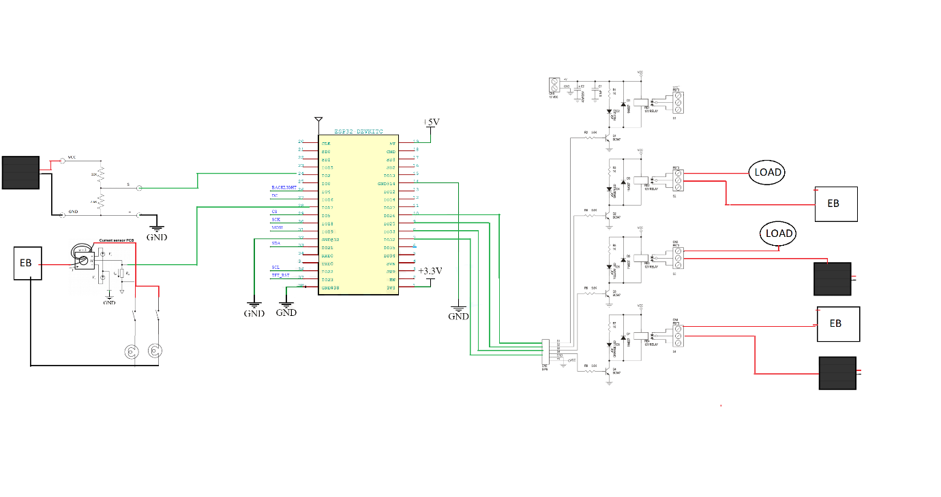

**Solar Panel:**

# TECHNICAL DATA

**Electrical Data** : All Data refers to STC (1000W/m2, AM1.5G, 25°C)

|  |  |  |  |  |  |
| --- | --- | --- | --- | --- | --- |
| **Model Name** | **LGV12V40** | **LGV12V50** | **LGV12V75** | **LGV12V100** | **LGV12V160** |
| **Peak Power Pmax (Wp)** | 40 | 50 | 75 | 100 | 160 |
| **Maximum Voltage Vmp (V)** | 17.50 | 18.00 | 18.00 | 18.00 | 18.20 |
| **Maximum Current Imp (A)** | 2.46 | 2.78 | 4.17 | 5.66 | 8.79 |
| **Open Circuit Voltage Voc (V)** | 21.00 | 22.00 | 22.00 | 22.00 | 22.20 |
| **Short Circuit Current Isc (A)** | 2.54 | 3.28 | 4.67 | 6.06 | 9.34 |
| **Maximum System Voltage** | 600 VDC | 600 VDC | 600 VDC | 600 VDC | 1000 VDC |
| **Max Rated Current Series (Fuse Rating)** | 6A | 6A | 6A | 10A | 15A |
| **Solar Cell Size (in mm)** | 39x156.75 | 52x156.75 | 78x156.75 | 99x156.75 | 156.75x156.75 |
| **No. of Solar Cells per module** | 36 | 36 | 36 | 36 | 36 |

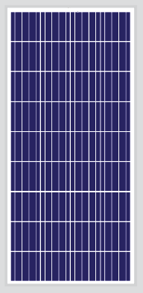

STC :1000W/m2 Irradiance, 25°C Cell Temperature, AM1.5G Spectrum according to EN 60904-3 Average relative effciency reduction of < 5% at 200W/m2 according to

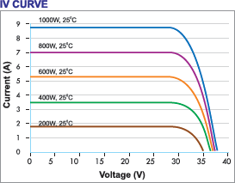

**Esp32**

# Product Overview

ESP32 is a single 2.4 GHz Wi-Fi-and-Bluetooth combo chip designed with the TSMC low-power 40 nm technology. It is designed to achieve the best power and RF performance, showing robustness, versatility and reliability in a wide variety of applications and power scenarios.

The ESP32 series of chips includes ESP32-D0WD-V3, ESP32-D0WDR2-V3, ESP32-U4WDH, ESP32-S0WD [(NRND)](https://www.espressif.com/en/products/longevity-commitment?id=nrnd), ESP32-D0WDQ6-V3 [(NRND)](https://www.espressif.com/en/products/longevity-commitment?id=nrnd), ESP32-D0WD [(NRND)](https://www.espressif.com/en/products/longevity-commitment?id=nrnd), and ESP32-D0WDQ6 [(NRND)](https://www.espressif.com/en/products/longevity-commitment?id=nrnd), among

which,

* ESP32-S0WD [(NRND)](https://www.espressif.com/en/products/longevity-commitment?id=nrnd), ESP32-D0WD [(NRND)](https://www.espressif.com/en/products/longevity-commitment?id=nrnd), and ESP32-D0WDQ6 [(NRND)](https://www.espressif.com/en/products/longevity-commitment?id=nrnd) are based on chip revision v1 or chip revision v1.1.
* ESP32-D0WD-V3, ESP32-D0WDR2-V3, ESP32-U4WDH, and ESP32-D0WDQ6-V3 [(NRND)](https://www.espressif.com/en/products/longevity-commitment?id=nrnd) are based on

chip revision v3.0 or chip revision v3.1.

For details on part numbers and ordering information, please refer to Section 1 ESP32 Series Comparison. For details on chip revisions, please refer to [*ESP32 Chip Revision v3.0 User Guide*](https://www.espressif.com/sites/default/files/documentation/ESP32_ECO_V3_User_Guide__EN.pdf)and

[*ESP32 Series SoC Errata*](https://www.espressif.com/sites/default/files/documentation/eco_and_workarounds_for_bugs_in_esp32_en.pdf).

The functional block diagram of the SoC is shown below.



In-Package Flash or PSRAM

SPI

I2C I2S SDIO UART

TWAI® ETH

RMT PWM

Touch sensor DAC ADC

Timers

Bluetooth link controller

Bluetooth baseband

Wi-Fi MAC

Wi-Fi baseband

RF

receive

Clock generator

RF

transmit

Core and memory

2 (or 1) x Xtensa® 32-bit LX6 Microprocessors

Cryptographic hardware acceleration

SHA

RSA

ROM

SRAM

AES

RNG

RTC

PMU

ULP

coprocessor

Recovery memory

## Features

Wi-Fi

* 802.11b/g/n
* 802.11n (2.4 GHz), up to 150 Mbps WMM
* TX/RX A-MPDU, RX A-MSDU
* Immediate Block ACK
* Defragmentation
* Automatic Beacon monitoring (hardware TSF)
* 4 × virtual Wi-Fi interfaces
* Simultaneous support for Infrastructure Station, Soft AP, and Promiscuous modes

Note that when ESP32 is in

Station mode, performing a scan, the Soft AP channel will be changed.

* Antenna diversity

Bluetooth®

* Compliant with Bluetooth v4.2 BR/EDR and Bluetooth LE specifications
* Class-1, class-2 and class-3 transmitter without external power amplifier
* Enhanced Power Control
* +9 dBm transmitting power
* NZIF receiver with –94 dBm Bluetooth LE sensitivity
* Adaptive Frequency Hopping (AFH)
* Standard HCI based on SDIO/SPI/UART
* High-speed UART HCI, up to 4 Mbps
* Bluetooth 4.2 BR/EDR and Bluetooth LE dual mode controller
* Synchronous Connection-Oriented/Extended (SCO/eSCO)
* CVSD and SBC for audio codec
* Bluetooth Piconet and Scatternet
* Multi-connections in Classic Bluetooth and Bluetooth LE
* Simultaneous advertising and scanning

CPU and Memory

* Xtensa® single-/dual-core 32-bit LX6 microprocessor(s)
* CoreMark® score: 1 core at 240 MHz: 504.85 CoreMark; 2.10 CoreMark/M

Clocks and Timers

* Internal 8 MHz oscillator with calibration
* internal RC oscillator with calibration
* External 2 MHz ~ 60 MHz crystal oscillator (40 MHz only for Wi-Fi/Bluetooth functionality)
* External 32 kHz crystal oscillator for RTC with calibration
* Two timer groups, including 2 × 64-bit timers and 1 × main watchdog in each group
* One RTC timer
* RTC watchdog

Advanced Peripheral Interfaces

* 34 × programmable GPIOs
* 5 strapping GPIOs
* 6 input-only GPIOs
* 6 GPIOs needed for in-package flash/PSRAM (ESP32-D0WDR2-V3, ESP32-U4WDH)
* 12-bit SAR ADC up to 18 channels
* 2 × 8-bit DAC
* 10 × touch sensors
* 4 × SPI
* 2 × I2S
* 2 × I2C
* 3 × UART
* 1 host (SD/eMMC/SDIO)
* 1 slave (SDIO/SPI)
* Ethernet MAC interface with dedicated DMA and IEEE 1588 support
* TWAI®, compatible with ISO 11898-1 (CAN Specification 2.0)
* RMT (TX/RX)
* Motor PWM

## Pin Layout

CAP1 CAP2 VDDA XTAL_P XTAL_N VDDA GPIO21 UОTXD UОRXD GPIO22 GPIO19

VDD3P3_CPU

VDDA 1

48

47

46

45

44

43

42

41

40

39

38

37

LNA_IN 2

VDD3P3 3

VDD3P3 4

SENSOR_VP 5

SENSOR_CAPP 6

SENSOR_CAPN 7

SENSOR_VN 8

CHIP_PU 9

VDET_1 10

36 GPIO23

35 GPIO18

ESP32 49 GND

34 GPIO5

33 SD_DATA_1

32 SD_DATA_О

31 SD_CLK

30 SD_CMD

29 SD_DATA_3

28 SD_DATA_2

27 GPIO17

VDET_2 11

32K_XP 12

26 VDD_SDIO

32K_XN GPIO25 GPIO26 GPIO27 MTMS MTDI

VDD3P3_RTC

MTCK

MTDO GPIO2 GPIOО GPIO4

25 GPIO16

13

14

15

16

17

18

19

20

21

22

23

24

CAP1 CAP2 VDDA XTAL_P XTAL_N VDDA GPIO21 UOTXD UORXD

GPIO22

VDDA LNA_IN VDD3P3 VDD3P3 SENSOR_VP SENSOR_CAPP SENSOR_CAPN SENSOR_VN CHIP_PU VDET_1 VDET_2 32K_XP

48

47

46

45

44

43

42

41

40

39

32K_XN GPIO25

15

16

17

18

19

20

21

22

23

24

1

2

3

4

5

6

7

8

9

10

11

12

13

14

38 GPIO19

37 VDD3P3_CPU

ESP32 49 GND

36 GPIO23

35 GPIO18

34 GPIO5

33 SD_DATA_1

32 SD_DATA_O

31 SD_CLK

30 SD_CMD

29 SD_DATA_3

28 SD_DATA_2

27 GPIO17

26 VDD_SDIO

25 GPIO16

**Voltage Sensor**

**Voltage Sensor** is a precise low-cost sensor for measuring voltage. It is based on the principle of resistive voltage divider design. It can make the red terminal connector input voltage to 5 times smaller

### **Voltage Sensor Module Pinout Configuration**

|  |  |
| --- | --- |
| **Pin Name** | **Description** |
| VCC | Positive terminal of the External voltage source (0-25V) |
| GND | Negative terminal of the External voltage source |
| S | Analog pin connected to Analog pin of Arduino |
| + | Not Connected |
| - | Ground Pin connected to GND of Arduino |

### **Voltage Detection Sensor Module Features & Specifications**

* Input Voltage: 0 to 25V
* Voltage Detection Range:  0.02445 to 25
* Analog Voltage Resolution: 0.00489V
* Needs no external components
* Easy to use with Microcontrollers
* Small, cheap and easily available
* Dimensions: 4 × 3 × 2 cm

### **Brief about Voltage Sensor Module**

Voltage Detection Sensor Module is a simple and very useful module that uses a potential divider to reduce any input voltage by a factor of 5. This allows us to use the Analog input pin of a microcontroller to monitor voltages higher than it capable of sensing. For example, with a 0V - 5V Analog input range, you are able to measure a voltage up to 25V. This module also includes convenient screw terminals for easy and secure connections of a wire.

The internal **circuit diagram of the Voltage Sensor Module** is given below.

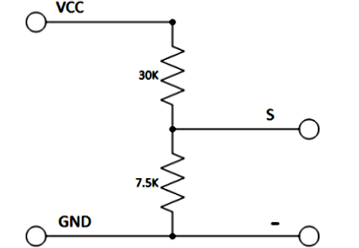

The voltage circuit consists of a voltage divider circuit of two resistors in which R1 is 30K and R2 is 7.5K.

**Current Sensor**

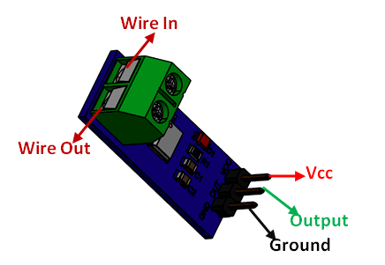

### **Pin Configuration**

|  |  |  |
| --- | --- | --- |
| **Pin Number** | **Pin Name** | **Description** |
| 1 | Vcc | Input voltage is +5V for typical applications |
| 2 | Output | Outputs Analog voltage proportional to current |
| 3 | Ground | Connected to ground of circuit |
| T1 | Wire In | The wire through current has to be measured is connected here |

### **Specifications**

* Measures both AC and DC current
* Available as 5A, 20A and 30A module
* Provides isolation from the load
* Easy to integrate with MCU, since it outputs analog voltage
* Scale Factor

|  |  |  |
| --- | --- | --- |
| * 5A Module | * 20A Module | * 30A Module |
| * 185mV/Amp | * 100mV/Amp | * 66mV per Amp |

### **Where to use ACS712 Module**

The **ACS712 Module** uses the famous **ACS712 IC** to **measure current** using the Hall Effect principle. The module gets its name from the IC (ACS712) used in the module, so for you final products use the IC directly instead of the module.

These ACS712 module can measure current AC or DC current ranging from +5A to -5A, +20A to -20A and +30A to -30A. You have to select the right range for your project since you have to trade off accuracy for higher range modules. This modules outputs Analog voltage (0-5V) based on the current flowing through the wire; hence it is very easy to interface this module with any [microcontroller](https://components101.com/microcontrollers). So if you are looking for a module to measure current using a microcontroller for you project, then this module might be the right choice for you.

### **How to use the ACS712 Module**

As told earlier it is very simple to **interface the ACS712 Module with Microcontrollers**. The below diagram would be more illustrative

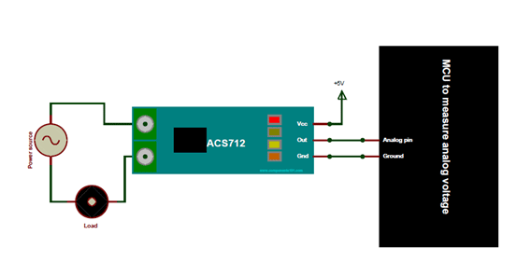

# Weather sensing portion from cloud server:

Raspberry Pi will collect the weather information data from internet server to optimize the usage of power supply of solar power over the main grid.

# Energy monitoring portion:

Energy generated by solar panels will charge the batteries via charging controller. In the case bad weather condition of next day’s information collected by the raspberry pi, the system will optimize the usage of stored power supply. If the battery runs out of the power, appliances will get a supply from main grid.

# Controlling appliances:

Raspberry Pi will collect info/data from the device via Controller how much current consumed by each appliance. We have taken examples of 4 power ports; Controller is used for

the communication between raspberry and Arduino. Controller coordinator will request the data from Controller endpoint which is connected to Arduino. ZigBee has to be configured initially whether it should act as Controller coordinator, Controller router or Controller endpoint using XCTU software. Arduino is used for creating the functionality of the end devices (light etc.), For example we have connected one DC light and DC Fan to Arduino, the light intensity and fan speed will controlled by Arduino according to user given value, comparing with sensors value. Arduino will act as ZigBee end device which will give control commands to the devices like fan, light and other appliances.

# Results and Conclusions

1. Using weather prediction, the system decides whether the appliances must rely on solar or grid to supply electricity for home appliance.
2. Dash board will have the complete information of the energy consumed by the devices and the power utilized from solar and grid.
3. With this concept the user can reduce the power consumption from the grid and if there is less power utilized and more power generated by solar, the excess power can be exported to grid and the user can make a revenue from it.

**REFERENCES:**

1. Energy Management System in Smart Grid:<https://www.rsisinternational.org/Issue21/31-48>
2. Artificial Intelligence Techniques for the Smart Grid by Nick Bassiliades; Georgios Chalkiadakis -January 2018: [https://www.researchgate.net/publication/321510769_Artificial_Intelligence_Techniques_for_t](https://www.researchgate.net/publication/321510769_Artificial_Intelligence_Techniques_for_the_Smart_Grid/link/5a97a7770f7e9ba42974e003) [he_Smart_Grid/link/5a97a7770f7e9ba42974e003](https://www.researchgate.net/publication/321510769_Artificial_Intelligence_Techniques_for_the_Smart_Grid/link/5a97a7770f7e9ba42974e003)
3. Application and prospect of artificial intelligence in smart grid by JianJiao: <https://iopscience.iop.org/article/10.1088/1755-1315/510/2/022012>
4. Design of a Solar Power Management System for an Experimental UAV: November 2009 <https://www.researchgate.net/publication/224612302>
5. A hybrid network smart home based on Zigbee and smart plugs: <https://ieeexplore.ieee.org/document/8418572>
6. Review and Performance Analysis on Wireless Smart Home and Home Automation using IoT : <https://ieeexplore.ieee.org/document/9032629>
7. [Smart Home with ZigBee](https://ieeexplore.ieee.org/document/6885403) [: https://ieeexplore.ieee.org/document/6885403](https://ieeexplore.ieee.org/document/6885403)
8. [Smart Home Based on the ZigBee wireless: https://ieeexplore.ieee.org/document/6376500](https://ieeexplore.ieee.org/document/6376500)